A2-1: HOP Screenshots

2.1 HOP

2.2 HOP

2.3 HOP

2.4 HOP

2.5 HOP

2.6 HOP

2.7 HOP

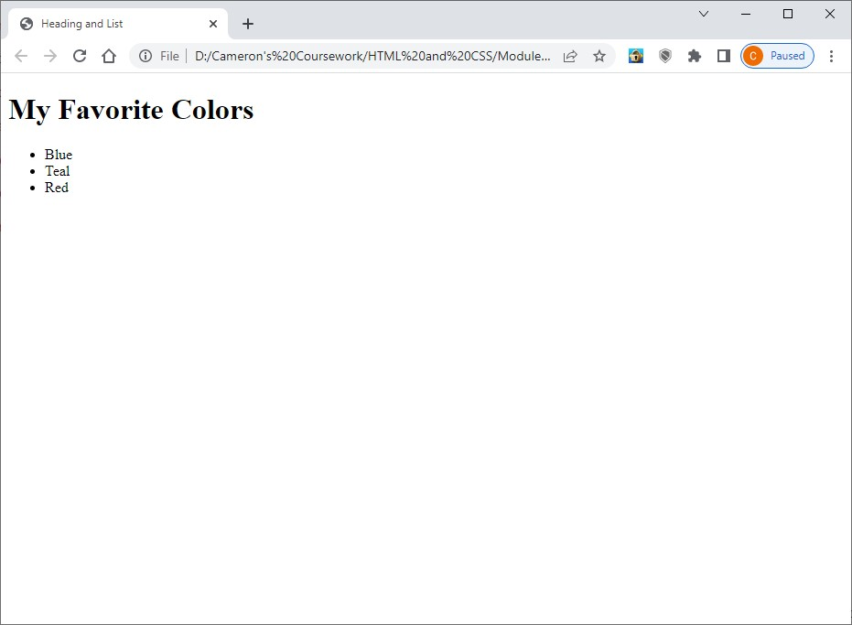

2.8 HOP

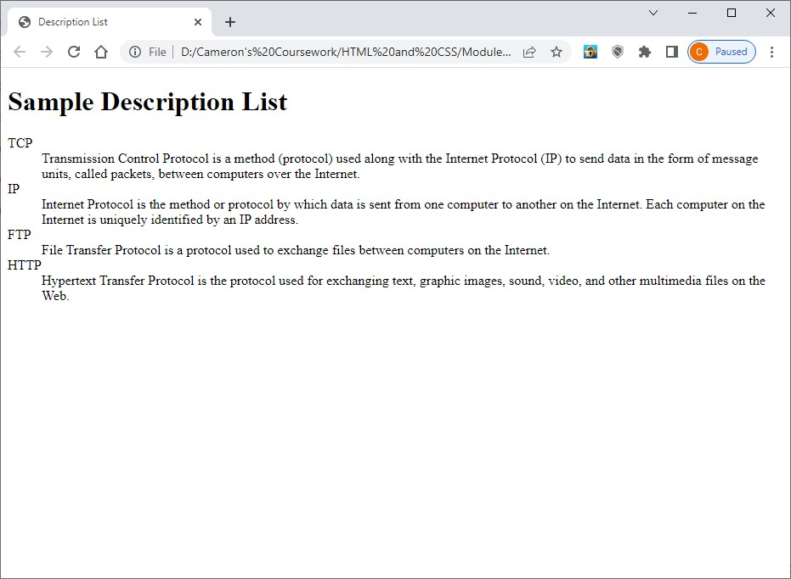

2.9 HOP

2.10 HOP

2.11 HOP

2.12 HOP

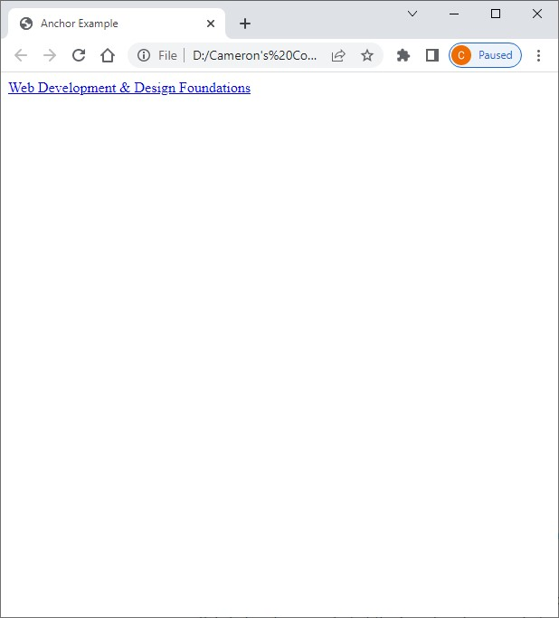

2.13 HOP – Contact Page

2.13 HOP – Index Page

2.13 HOP – Services Page

2.14 HOP

2.15 HOP – Before

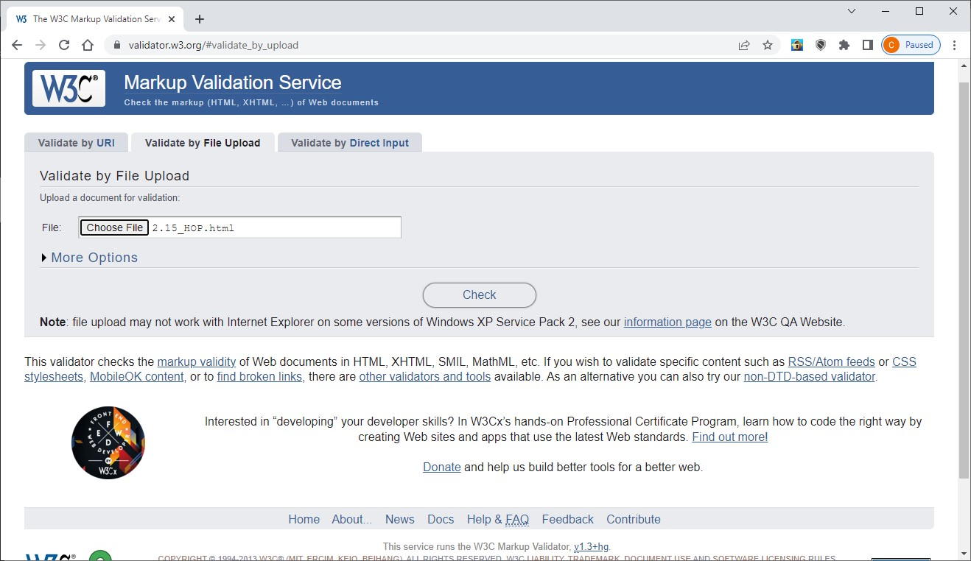

2.15 HOP – After

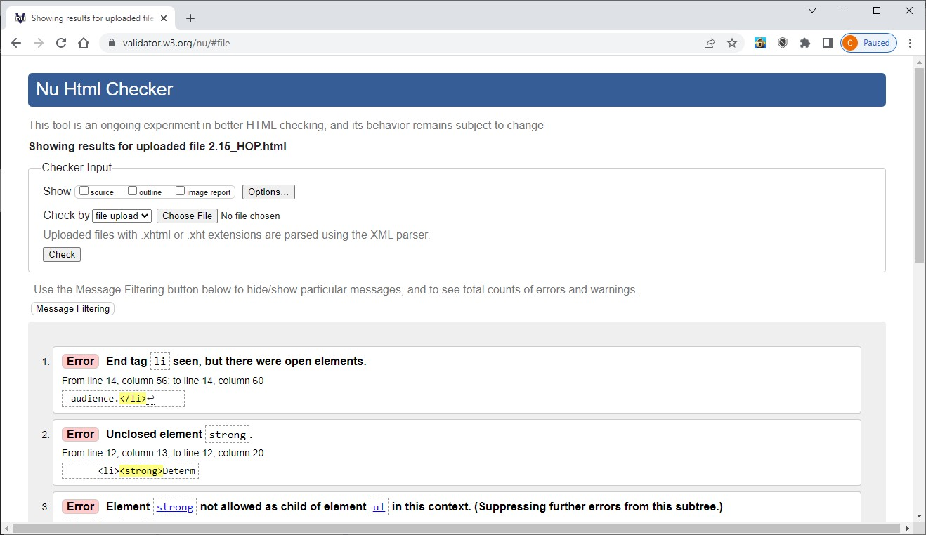

2.15 HOP – Final

